Book

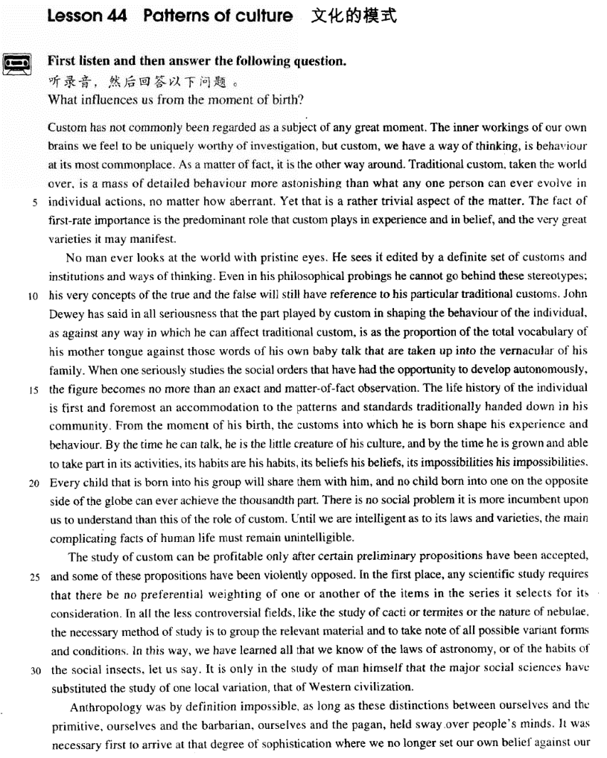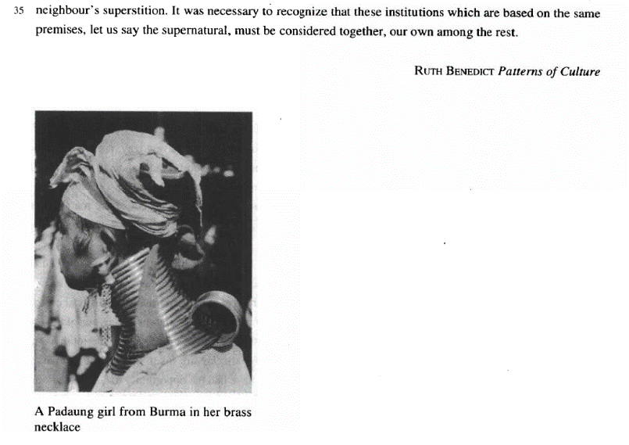

课文

Custom has not commonly been regarded as a subject of any great moment.

风俗一般未被认为是什么重要的课题。

The inner workings of our own brains we feel to be uniquely worthy of investigation,

我们觉得，只有我们大脑内部的活动情况才值得研究，

but custom, we have a way of thinking, is behaviour at is most commonplace.

至于风俗呢，只是些司空见惯的行为而已。

As a matter of fact, it is the other way around.

事实上，情况正好相反。

Traditional custom, taken the world over, is a mass of detailed behaviour more astonishing than what any one person can ever evolve in individual actions, no matter how aberrant.

从世界范围来看，传统风俗是由许多细节性的习惯行为组成，它比任何一个养成的行为都更加引人注目，不管个人行为多么异常。

Yet that is a rather trivial aspect of the matter.

这只是问题的一个次要的侧面。

The fact of first-rate importance is the predominant role that custom plays in experience and in belief, and the very great varieties it may manifest.

最重要的是，风俗在实践中和信仰上所起的举足轻重的作用，以及它所表现出来的极其丰富多采的形式。

No man ever looks at the world with pristine eyes.

没有一个人是用纯洁而无偏见的眼光看待世界。

He sees it edited by a definite set of customs and institutions and ways of thinking.

人们所看到的是一个受特定风俗习惯、制度和思想方式剪辑过的世界。

Even in his philosophical probings he cannot go behind these stereotypes;

甚至在哲学领域的探索中，人们也无法超越这此定型的框框。

his very concepts of the true and the false will still have reference to his particular traditional customs.

人们关于真与伪的概念依然和特定的传统风俗有关。

John Dewey has said in all seriousness that the part played by custom in shaping the behaviour of the individual, as against any way in which he can affect traditional custom,

约翰.杜威曾经非常严肃地指出：风俗在形成个人行为方面所起的作用和一个对风俗的任何影响相比，

is as the proportion of the total vocabulary of his mother tongue against those words of his own baby talk that are taken up into the vernacular of his family.

就好像他本国语言的总词汇量和自己咿呀学语时他家庭所接纳的他的词汇量之比。

When one seriously studies the social orders that have had the opportunity to develop autonomously, the figure becomes no more than an exact and matter-of-fact observation.

当一个人认真地研究自发形成的社会秩序时，杜威的比喻就是他实事求是观察得来的形象化的说法。

The life history of the individual is first and foremost an accommodation to the patterns and standards traditionally handed down in his community.

个人的生活史首先是适应他的社团世代相传形成的生活方式和准则。从他呱呱坠地的时刻起，他所生于其中的风俗就开始塑造他的经历和行为规范。

From the moment of his birth, the customs into which he is born shape his experience and behaviour. By the time he can talk, he is the little creature of his culture, and by the time he is grown and able to take part in its activities,

到会说话时，他就是传统文化塑造的一个小孩子；等他长大了，能做各种事了，他的社团的习惯就是他的习惯，他的社团的信仰就是他的信仰，他的社团不能做的事就是他不能做的事。

its habits are his habits, its beliefs his beliefs, its impossibilities his impossibilities. Every child that is born into his group will share them with him, and no child born into one on the opposite side of the globe can ever achieve the thousandth part. There is no social problem it is more incumbent upon us to understand than this of the role of custom.

每一个和他诞生在同一个社团中的孩子和他一样具有相同的风俗；而在地球的另一边，诞生在另一个社团的孩子与他就是少有相同的风俗。没有任何一个社会问题比得上风俗的作用问题更要求我们对它理解。

Until we are intelligent as to its laws and varieties, the main complicating facts of human life must remain unintelligible.

直到我们理解了风俗的规律性和多样性，我们才能明白人为生活中主要的复杂现象。

The study of custom can be profitable only after certain preliminary propositions have been accepted, and some of these propositions have been violently opposed.

只有在某些基本的主张被接受下来、同时有些主张被激烈反对时，对风俗的研究才是全面的，才会有收获。

In the first place, any scientific study requires that there be no preferential weighting of one or another of the items in the series it selects for its consideration.

首先，任何科学研究都要求人们对可供考虑的诸多因素不能厚此薄彼，偏向某一方面。

In all the less controversial fields, like the study of cacti or termites or the nature of nebulae,

在一切争议较小的领域里，如对仙人掌、白蚁或星云性质的研究，

the necessary method of study is to group the relevant material and to take note of all possible variant forms and conditions.

应采取的研究方法是把有关各方面的材料汇集起来，同时注意任何可能出现的异常情况和条件。

In this way, we have learned all that we know of the laws of astronomy, or of the habits of the social insects, let us say.

例如，用这种方法，我们完全掌握了天文学的规律和昆虫群居的习性。

It is only in the study of man himself that the major social sciences have substituted the study of one local variation, that of Western civilization.

只是在对人类自身的研究。主要的社会科学建立在本土变化，即西方文明上。

Anthropology was by definition impossible, as long as these distinctions between ourselves and the primitive, ourselves and the barbarian, ourselves and the pagan, held sway over people's minds.

只要我们同原始人，我们同野蛮人，我们同异教徒之间存有的区别在人的思想中占主工导地位，那么人类学按其定义来说就无法存在。

It was necessary first to arrive at that degree of sophistication where we no longer set our own belief against our neighbour's superstition.

我们首先需要达到这样一种成熟的程度：不用自己的信仰去反对我们邻居的迷信。

It was necessary to recognize that these institutions which are based on the same premises, let us say the supernatural, must be considered together, our own among the rest.

必须认识到，这些建立在相同前提基础上的风俗，暂且可以说是超自然的东西，必须放在一起加以考虑，我们自己的风俗和其他民族的风俗都在其中。

词汇讲解

Lesson 44 Patterns of culture

predominant [prɪ'dɒmɪnənt]

adj. 显著的，主要的，多数的

predominant adj. more noticeable or important, or larger in number, than others 显著的，主要的，多数的

Research forms the predominant part of my job.

Dancers have a predominant role in this performance. predominate v. 占多数，最重要，最显著

In older age groups women predominate because men tend to die

younger.

Private interest was not allowed to predominate over the public good. predominance n. 多数，优势

a predominance of boys in the class

Britain's naval predominance

“dom” = rule

dominate v. 统治，支配，占优势dominant adj. 最重要的，占支配地位的domination n. 统治，支配

dominion n. 统治，管辖；领土，版图

predominate “pre” = before v. 占多数，最重要，最显著predominant adj. 显著的，主要的，多数的predominance n. 多数，优势

incumbent [ɪn'kʌmbənt]

adj. 有责任，有义务，必须履行的；现任的

incumbent adj. 1. necessary as part of sb’s duty 有责任，有义务，必须履行的

incumbent on / upon sb.

It is incumbent upon all users of this equipment to familiarize themselves with the safety procedure.

incumbent adj. 2. having an official position 现任的

the incumbent president “cumb” = lie down

incumbent “in” = into adj. 有责任，有义务，必须履行的；现任的

encumber “en” = in v. 妨碍，阻碍

cumbersome “some”（形容词后缀）adj. 笨重的concubine “con” = together n. 妾，姨太太，小老婆succumb “sub” = under v. 屈从，服从

recumbent “re” = back adj. 躺着的

cactus ['kæktəs]

n. 仙人掌

cactus ➔ 复数 cacti / cactuses stimulus ➔ 复 数 stimuli bacillus ➔ 复 数 bacilli alumnus ➔ 复 数 alumni nebula ['nebjələ]

n. 星云

nebula n. a mass of gas and dust among the stars, which often appears as a bright cloud in the sky at night 星云

nebula ➔ 复数 nebulae

larva ➔ 复 数 larvae alumna ➔ 复 数 alumnae barbarian [bɑ:'beəriən]

n. 野蛮人；没有教养的人

barbarian n. 1. a member of a group of people from a very different country or culture that is considered to be less socially advanced and more violent than your own 野蛮人

barbarian invasions of the fifth century

barbarian n. 2. a person with little education who has no interest in art and culture 没有教养的人

How can you call those barbarians your friends?

barbarous = barbaric adj. 野蛮的

the barbarous treatment of these prisoners of war

It's a devastating and barbaric act that defies all comprehension. civilized adj. 文明的

Such things should not be allowed to happen in a civilized society.

barbarism n. 野蛮

The terrorist attack was condemned as an act of barbarism and cowardice. civilization n. 文明

Each civilization is born, it culminates, and it decays.

sophistication [sə7fɪstɪ'keɪʃn]

n. 高级，复杂，先进；老练，世故； 聪明，有经验，理解力强sophistication n. 1. the sophistication of machines or methods is their quality of being more advanced or complex than others 高级，复杂，先

进

Given the sophistication of modern machines, there is little that cannot be successfully washed at home.

sophistication n. 2. the quality of being comfortable in social situations and knowing about culture, fashion, and other matters that are considered socially important 老练，世故

She spoke simply and directly, without sophistication.

sophistication n. 3. the quality of being intelligent and knowing a lot, so that you are able to understand complicated situations 聪明，有经验，理解力强

computer users with a high degree of sophistication

sophisticated adj. 1. (of machine, device, or method) more advanced or complex than others 高级的，复杂的，先进的

sophisticated modern weapons

Bees use one of the most sophisticated communication systems of any insect.

sophisticated adj. 2. comfortable in social situations and knows about culture, fashion, and other matters that are considered socially important 老练的，世故的

He was older than me and from London and I thought him very

sophisticated.

sophisticated adj. 3. intelligent and knows a lot, so that they are able to understand complicated situations 聪明的，有经验的，理解力强的Consumers are getting more sophisticated and more demanding.

Custom has not commonly been regarded as a subject *of great moment*. commonly adj. usually; widely 通常；广泛地

The disease is commonly known as mad cow disease.

a commonly used industrial chemical

moment n. outstanding significance or value, importance 重要

… of great moment

a discovery of great moment

momentous adj. vital, crucial, key, critical 重要的，重大的，关键的

The inner workings of our own brains we feel *to be uniquely worthy of*

*investigation*, but custom, *we have a way of thinking*, is behaviour at its

most commonplace.

the workings of sth.: the way that an organization, machine or organism operates 工作方式，运作方式，运转方式

the workings of government

the workings of a car engine

The inner workings of our own brains we feel *to be uniquely worthy of*

*investigation*, …

We feel the inner workings of our brains *to be uniquely worthy of*

*investigation*, …

Smoking he absolutely loathes. That John is a thief I can’t believe.

The president praised the loyalists, but the rebels he declared traitors.

不患人之不己知 患不知人也

硕鼠硕鼠 无食我黍三岁贯女 莫我肯顾

微斯人 吾谁与归

He has proved them wrong.

He has proved wrong the forecasts made by the country’s leading

economic experts.

In 1928 some porpoises were photographed working like beavers to push ashore a waterlogged mattress.

It has to be tall because it is like a giant block and tackle, and we have to lower into the ground and haul out of the ground great lengths of drill

pipe which are rotated by an engine at the top and are fitted with a cutting

bit at the bottom. be worthy of n.

be worthy to do / to be done

... to be uniquely worthy to be investigated … be worth n. / doing

… to be uniquely worth investigation …

… to be uniquely worth investigating …

have a way of doing sth.: often or usually do sth. 往往，常常

Ruth has a way of ignoring me that drives me mad.

…, we usually think, …

commonplace adj. happening or existing in many places, and therefore not special or unusual 寻常的，司空见惯的，不足为奇的

All these computer uses have become commonplace.

at one’s + 形容词最高级 处于……最……的状态

At the age of twelve years, the human body is at its most vigorous. The garden is at its most beautiful in June.

Caesar was at his most powerful when he conquered Gaul.

*As a matter of fact*, it is the other way around. the other way around / round

I thought he was the boss and she was his secretary, but in fact it was the other way around.

the opposite

The other side of the picture is quite the opposite. the contrary

I was worried that it might be too difficult for me but I found the contrary. the reverse

The teachers say my son is slow, but I believe the reverse. the antithesis

She is slim and shy―the very antithesis of her sister.

Traditional custom, taken the world over, is a mass of detailed behaviour

*more astonishing than what any one person can ever evolve in individual*

*actions, no matter how aberrant*. the world over

all over the world throughout the world around the world

a mass of… / masses of…

a lot of… / lots of…

This caused the construction of gigantic buildings where too large masses of human beings are crowded together.

evolve v. to develop and change gradually 演变

Popular music evolved from folk songs.

The group gradually evolved into a political party.

Animals have evolved camouflage to protect themselves from predators. evolution

Darwin’s theory of evolution

“volve”转

evolve involve revolve The earth revolves around the sun.

aberrant adj. abnormal 异常的

Taking drugs may result in aberrant behavior. Yet that is a rather trivial aspect of the matter.

trivial adj. not serious, important, or valuable 微不足道的

a trivial detail / matter / problem

I know it sounds trivial, but I'm worried about it.

The fact *of first-rate importance* is the predominant role that custom plays *in experience* and *in belief*, and the very great varieties it may manifest.

of … importance

The cultivation of a hobby and new forms of interest is therefore a policy of the first importance to a public man.

play a … role / part in … variety n. 1. [C] 种类

Scientists discovered that this particular variety of rabbit (and apparently

no other animal) was susceptible to a fatal virus disease, myxomatosis.

No two sorts of birds practise quite the same sort of flight; the varieties are infinite; but two classes may be roughly seen.

variety 2. [U] 千变万化，多样性

There is so much variety that you never have to make do with second best.

Today, enough soundings are available to enable a relief map of the Atlantic to be drawn and we know something of the great variety of the sea bed's topography.

a variety of … 各种各样的

By comparison, trips by sea offer a great variety of civilized comforts. manifest vt. 使……显露出来

Musical talent usually manifests itself in childhood.

manifest adj. 明显的

Surely because progress of a particular kind is actually taking place around us and is becoming more and more manifest.

No man ever looks at the world *with pristine eyes*. pristine adj. extremely clean or new 纯洁的，全新的He has a pristine reputation.

The bike was in pristine condition.

He sees it edited by a definite set of customs and institutions and ways of

thinking.

institution 1. [C] 大型机构

a financial / educational / charitable institution institution 2. [C] 风俗习惯

Drinking tea at 4 pm is a popular British institution.

As can be seen in this cartoon, a soccer player is on the point of making a penalty kick whereas a goalkeeper is preparing himself for it. Two different images pop up in their minds at the same time: the attacker is under the illusion that the goalkeeper is as big as the goal so that it is almost impossible for him to shoot in while the keeper, on the other hand, is daunted by the delusion that he turns helpless dwarf guarding a gigantic goal.

The lesson we can draw from this picture is clear and simple: all too often one overestimates the challenges and difficulties he faces and underrates his capabilities to cope with them. No man ever looks at this world with pristine eyes. He sees it edited by his own feelings and ways of thinking. This is especially the case when one is at a critical time in his life. Fears and tension preoccupy him at this very moment, truth distorted and confidence destroyed.

To calm his nerves and pluck up his courage, he has to realize what the truth is and admit that it is not the end of the world if he fails at this time. Then gradually, and often quite swiftly, the process of recuperation begins

and a better result may be anticipated.

Even in his philosophical probings he cannot go behind these stereotypes; his very concepts of the true and the false will still have reference to his particular traditional customs.

probe v. to ask questions in order to find out secret or hidden information about sb./sth. 打探，探究，调查

He didn’t like the media probing into his past.

a TV programme that probed government scandals in the 1990s stereotype n. [C] image, idea, character, etc. that has become fixed or

standardized in a conventional form without individuality 陈规，老一套，

旧框框

He doesn’t conform to the usual stereotype of the city businessman with a dark suit and rolled umbrella. 他不像典型的城市商人那样, 穿一身深色的西装、带一把收好的雨伞。

prototype n. [C] first or original example of sth. that has been or will be

copied or developed; model or preliminary version 事物之原始形态，原型，雏形，模型，蓝本

the prototype for future school buildings 未来的学校建筑的模型

a prototype supersonic aircraft 超音速飞机的样机

very adj. (used to emphasize a n. 用以加强名词的语气)

He knows our very thoughts. 他了解我们内心深处的想法。

The very idea of going abroad delighted him. 他想到出国一事就很欢喜。

have reference to … 与……有关

This has no reference to what we were discussing.

John Dewey has said in all seriousness that the part played by custom in

shaping the behaviour of the individual, as against any way *in which he*

*can affect traditional custom*, is as the proportion of the total vocabulary

*of his mother tongue* against those words *of his own baby talk that are*

*taken up into the vernacular of his family*. John Dewey

American philosopher, psychologist and educator A as against B is as C against D

The military power of the US, as against that of DPRK, is as the strength of an elephant against that of a mouse.

take sth⇔up: to accept a suggestion, offer, or idea 接受

Rob took up the invitation to visit.

vernacular n. [C] language or dialect spoken in a particular country or region, as compared with a formal or written language 本地话，方言土语

When one seriously studies the social orders that have had the

opportunity to develop autonomously, the figure becomes no more than

an exact and matter-of-fact observation. autonomous adj. 自治的，独立的

They proudly declared themselves part of a new autonomous province.

He treated us as autonomous individuals who had to learn to make up our own minds about important issues.

figure n. figure of speech 比喻

‘Get up with the lark’ is a figure (of speech), meaning 'Get out of bed early'.

no more than: only 只不过

It will take no more than five days to read the book. It's no more than a misunderstanding.

matter-of-fact adj. showing no emotion when you are talking about sth. exciting, frightening, upsetting etc. 不带个人情感的

She told us the news of his death in a very matter-of-fact way.

He was very matter-of-fact about the breakdown of his marriage.

observation n. remark or comment 言语，评论

She made one or two observations about the weather.

The life history of the individual is *first and foremost* an accommodation to the patterns and standards traditionally handed down in his community. first and foremost: more than anything else, firstly and most importantly

首要地，主要

He does a bit of writing, but first and foremost he’s a teacher.

First and foremost, we have to consider the morality of the enterprise． accommodation to sth. 对……的适应

the accommodation of my plans to yours accommodate to sth. 适应……

Her eyes took a while to accommodate to the darkness.

hand sth. down: pass sth. from older people to younger ones The recipe was handed down from an ancestor of the family.

The only way that they can preserve their history is to recount it as sagas—legends handed down from one generation of storytellers to another.

community n. a group of people who have the same interests, religion, race etc. 集体，群体

*From the moment of his birth*, the customs into which he is born shape his

experience and behaviour.

*By the time he can talk*, he is the little creature of his culture, and *by the time he is grown and able to take part in its activities*, its habits are his habits, its beliefs (are) his beliefs, its impossibilities (are) his impossibilities.

creature n. someone who is controlled or influenced a lot by sth. 产物，

奴隶，傀儡

creature of …

a creature of habit

He is a creature of the government.

Every child that is born into his group will share them with him, and no child *born into one on the opposite side of the globe* can ever achieve the thousandth part.

be born in / into …

I was born in Tokyo.

Meg was born into a large family.

share v. to have the same opinion, quality, or experience as sb. else 有 一样的，有共同的

I believe my view is widely shared. In some moods, Nature shares it. share sth. with sb.

People often share their political views with their parents. Stubbornness was a characteristic he shared with his mother.

There is no social problem (which) it is more incumbent upon us to

understand than this (social problem) of the role of custom. it is incumbent upon / on sb. to do sth.

It is incumbent upon parents to control what their children watch on TV.

The most valuable find of all was the ship's log book, parts of which it

was still possible to read.

But in an old man who has known human joys and sorrows, and has achieved whatever work it was in him to do, the fear of death is somewhat abject and ignoble.

Until we are intelligent as to its laws and varieties, the main complicating facts of human life must remain unintelligible.

intelligent adj. showing powers of understanding 能够理解的，了解的

The vast majority of us are not intelligent about the whole thing. as to prep. = about = with regard to 关于，对于

He was uncertain as to which road to take.

We are puzzled as to how it happened.

unintelligible adj. impossible to understand 不可能理解的，难懂的What he said was completely unintelligible to me because he used many technical terms.

The study of custom can be profitable only after certain preliminary

propositions have been accepted, and some of these propositions have

been violently opposed.

preliminary adj. coming before a more important action or event, preparatory 开端的，初步的，预备性的

after a few preliminary remarks

preliminary inquiries / experiments / negotiations

a preliminary contest

proposition n. statement that expresses a judgement or an opinion, assertion 观点，见解，主张

The proposition is so clear that it needs no explanation.

I approve of the proposition that love alone can waken love.

In the first place, any scientific study requires that there be no preferential weighting of one or another of the items in the series *it selects for its*

*consideration*.

In the first place, I’m too busy, and in the second, I don’t really want to go.

first / firstly first of all

to begin with to start with

preferential adj. of, giving, receiving or showing preference 优先的，给予优先的，得到优先的，优待的

Europe has given Caribbean banana growers preferential treatment for more than 20 years.

weight vt. [esp passive 尤用於被动语态] plan or organize (sth.) in a way

that favours a particular person or group, bias 计划或组织（某事物）使之偏向某人或某集体，使偏袒

a law weighted against those owning land 对土地持有者不利的法规

a law weighted in favour of those owning land 对土地持有者偏袒的法规

*In all the less controversial fields, like the study of cacti or termites or the*

*nature of nebulae,* the necessary method of study is to group the relevant

material and to take note of all possible variant forms and conditions. group v. to make sb./sth. form a group 使聚集，汇集

The children grouped themselves around their teacher.

All the multiple choice questions will be grouped together for convenience.

take note of sth. = pay attention to sth. = take notice of sth. 注意……

People were beginning to take note of her talents as a writer.

variant adj. having or exhibiting variation; differing 相异的，不同的

a variant form of the word

a variant form of oxygen known as ozone

variant n. [C] sth. which is slightly different from other similar things 变种，变体

variant on / of …

There are many colas on the market now, all variants on the original drink.

There are four variants of malaria, all transmitted to humans by a particular family of mosquitoes.

*In this way*, we have learned all that we know of the laws of astronomy, or of the habits of the social insects, *let us say*.

(let us) say: for example 比如说，例如

To see the problem here more clearly, let’s look at a different biological system, (let us) say, an acorn.

The Americans would happily reach one accord on standards for medical devices and then hammer out different pacts covering, say, electronic goods and drug manufacturing.

It is only in the study of man himself that the major social sciences have substituted the study of one local variation, that of Western civilization.

It is only in the study of man himself that the major social sciences have substituted the study of one local variation, that of Western civilization, (for the study of custom of all human beings).

substitute A for B replace B with A

You can substitute chicken for beef if you don’t like red meat. You can replace beef with chicken if you don’t like red meat.

Anthropology was *by definition* impossible, as long as these distinctions *between ourselves and the primitive, ourselves and the barbarian, ourselves and the pagan*, held sway over people's minds.

by definition: if sth. has a particular quality by definition, it must have

that quality because all things of that type have it 从本质上来说People say that students are by definition idealistic and impatient. Human perception is highly imperfect and by definition subjective.

hold sway: to be the main influence on people’s opinions or behavior 占主导地位

The traditional idea of wearing new clothes on New Year’s day seems no longer to hold sway.

It was necessary *first to arrive at that degree of sophistication where we no longer set our own belief against our neighbour's superstition*.

set … against …: make sb. oppose or be hostile to (a friend, relative, etc)

使某人反对或敌视（朋友、亲戚等）

The civil war set brother against brother.

She accused her husband of setting their children against her.

It was necessary *to recognize that these institutions which are based on*

*the same premises, let us say the supernatural, must be considered together, our own among the rest*.

premise n. statement or idea on which reasoning is based, hypothesis（推

理所依据的）前提，假定

Advice to investors was based on the premise that interest rates would continue to fall.

supernatural adj. that cannot be explained by natural or physical laws 超

自然的

supernatural beings, eg angels and devils

witch-doctors believed to have supernatural powers our own (being) among the rest

be among … 是……之一；包括在……之中

He was among the last to leave.

Among those present were the Prime Minister and her husband.

These ocean waves are among the earth's most complicated natural

phenomena.

dispute [dɪ'spju:t]